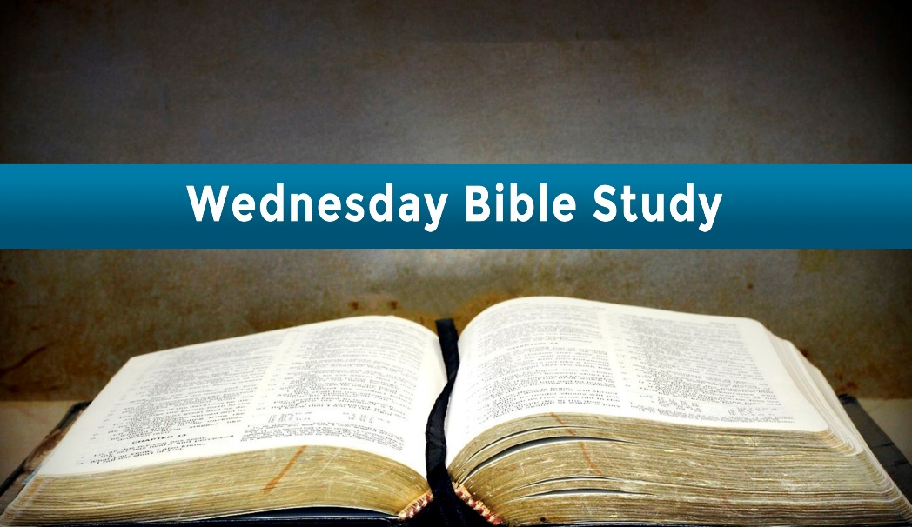

What frustrations and benefits arise from the way God measures time (**v. 8 – 9**)?

What does Peter mean when he says: **‘The day of the Lord will come like a thief in the night’**. (**v. 10**)?

There are groups of people who say that Jesus has already secretly returned. Based on Peter’s teaching, what can we say to them?

What will the coming judgment be like (**v. 7, 10**)?

God will create a new heaven and earth in place of the old (**v. 10 – 13**). How will life on earth be different than it is now?

Thinking about our hope for the future is much more than idle speculation. How can thinking about the future practically affect your way of thinking and acting (**v. 11 – 14**)?

In our Bible Studies we will be using a booklet from ‘A Life Builder Bible Study’ series. Our overall theme for these studies is: **CHRISTIAN BELIEFS.** The studies were originally written by Stephen Eyre, but we will be modifying them in order that they become more usable for both home study and Church study.

These studies give us the opportunity to study the Bible in a greater depth and to reflect on what it is saying to us.

If you are unable to be with us in church and have decided that you will be doing the studies from home, it is suggested that you do the study on a Wednesday morning, for an hour, starting at 10.30am. Get yourself a tea or coffee, a Bible, pen and paper (for any notes you want to make) and begin studying.

We do hope that you enjoy the studies that have been produced!

**Salendine Nook Baptist Church**

**2 Peter 3 v. 3 - 14**

**Now use the opportunity to PRAY about the things that you have learnt throughout these studies**

**Something to do LATER**

**Ask God to help you face the challenges of today with a strong hope for his future.**

Going outside onto a street at night you can easily have a sense that something is not quite safe.

After Jesus returns, the world is restored and the curse is removed, it will be safe to go out anywhere, at any time.

Try picturing yourself in a renewed world now.

How do you respond to the idea of being in a world where there is no more danger or pain?

**Something to do NOW**

Knowing what we believe is foundational to a healthy relationship with God and others. These studies on Christian Beliefs explore what Christians need to understand about some vital topics***:***

***God, Christ, The Holy Spirit, God’s Word, human nature, salvation, the church and the ‘last things’***.

Having a good grasp of these beliefs will equip us to make sense of the world we live in, strengthen our assurance of our own identity in Christ and direct us to a life of integrity.

**Some Thoughts To Help You While You Study**

In this final study on Christian Beliefs, the author of the studies, Stephen Eyre, says: ‘When I was a boy, my older brother used to get magazines that had futuristic drawings on the covers. Some magazines were science fiction; others were technical magazines about machines or cars. Whatever kind of magazine he bought; those cover illustrations had a mystical effect on me. They created an anxious hunger for the future, a hope for a glittering utopia of human civilisation run by amazing machines. Now, some forty or more years later, I am still waiting for the ‘future’. Granted, we have some amazing machines, but the dawning of utopia seems pretty far off. The Scriptures speak of the future, but its character and coming are different and far better than my childhood fantasies’.

This teaching about the future is called **Eschatology**.

**PERSONAL REFLECTION:** *Every so often certain groups of Christians proclaim that they have figured out the secret of the time of the return of Jesus Christ. How do you respond to such teaching? Why does a reflection on the teaching of the last things inspire so much excitement? What are you most looking forward to about the lord’s return?*

Glorification focuses on the personal condition of a believer on the other side of death. The study of eschatology is a consideration of the condition of the entire world when God completes his saving and restoring work of his fallen and rebellion creation.

**QUESTIONS TO THINK ABOUT:**

Looking over the whole passage, what are some things that the coming of the Lord involves?

We think of the last things as dealing with the future, but that is only part of it. How does the teaching on the last things look back to the past as well as to the future (**v. 1 – 7**)?

Christians can expect to encounter scoffers in the ‘last days’. What reasons do scoffers give for scoffing at the Lord’s coming (**v. 3 – 4**)?

Believers, too, are tempted to be discouraged and sceptical about the Lord’s return. How have you handled such struggles?

Why would scoffers want to forget about the creation and the flood?

How can recalling the creation and the flood strengthen our faith in the Lord’s return?

**STUDY 12**

**HOPE FOR THE FUTURE**

**Read 2 Peter 3 v. 3 - 14**

**The purpose of the study is:**

To find strength for living by looking for the return of

Jesus Christ.

The study of the ***‘last things’*** in Christian theology is called **Eschatology**. Central to Christian belief is the view that history will culminate in the coming of Jesus. At that time, God will judge the disobedient and vindicate the righteous (**Matthew 25 v. 31 – 46**). A Christian’s hope for the future is not merely for personal vindication and deliverance but for the judgment and restoration of all of creation (**Revelation 21**).

We are affected by those we associate with, especially when they care nothing about whether Jesus is coming back. Rather than consciously doubting the Lord’s return, we are tempted to let the issue slip into relative unimportance in the way we think and live.

Doubting is a struggle to believe. Scoffing is a choice not to believe. Those who choose not to believe certainly don’t want to acknowledge the fact that God judged disobedience in the past and will do so again in the future. Unbelief and scoffing are moral choices, not merely intellectual positions. God has called people to faith, and those who don’t believe make deliberate, even if unconscious, choices not to believe.

God has acted repeatedly in his world. There are times when we feel he is distant and uninvolved. By reflecting on what he has done in the past, we can have hope for the future.

God doesn’t measure time by human standards. We must adjust ourselves to his ways of time and not expect him to live to ours. Like an impatient child on a trip, we must wait. We can’t hurry God by constantly asking: ‘**Is it time yet?**’

A thief comes unexpectedly. Those who scoff will be completely surprised when the final day appears. Jesus’ return may be unexpected, but it will not be secret. This is the point of Jesus’ teaching as seen in (**Matthew 24 v. 26 – 31**).

One major result of the purification of the world will be the absence of evil and sin. We can hardly imagine a pure world. What would it be like to go on a walk at any time of day or night and never have the slightest fear? What would it be like to enter into any relationship and never have to be cautious or guarded?

We must never underestimate the power of hope. Hope for deliverance and vindication can keep us going in the hardest situations. We must not hope simply for a change in our personal circumstances but for a purifying judgment of God’s creation.